Assignment 4: GIT(Hub) Viz

|  |  |  |  |  |
| --- | --- | --- | --- | --- |
| **Student Name** | Yap Han Chiang | Yang Jung Kai |  |  |
| **Matriculation Number** | A0125168E | A0121593J |  |  |

# Introduction

This assignment required us to choose 2 from the 5 sample visualizations introduced in assignment 4 and used them to better visualize of data for repo [https://github.com/tungnk1993/scrapy found in assignment 3](https://github.com/tungnk1993/scrapy%20found%20in%20assignment%203). Team member Jung Kai have chosen to use pie chart to show the total number of commits made for the week from Monday to Sunday for the repo since it was created. Han Chiang has chosen to use a bar graph to show the weekly commit count of the contributors.

## 2. Visualizations - Purpose & Method

## 2.1 Pie Chart

Pie chart is used to show the total number of commits made from Monday and Sunday for the repo since it was created. The statistics for the pie chart was retrieved while doing assignment 3. We have used GITHub API to get all the commits for the week from Monday to Sunday since the repo was created using the link <https://api.github.com/repos/tungnk1993/scrapy/stats/punch_card>. We then used a calculator to sum up the total number of commits for the week from Monday to Sunday since the repo was created. Table 1 shows the result for total number of commits made for the week from Monday to Sunday and colors used to represent the day when creating the chart. Diagram 1 shows the chart created to represent the data in Table 1. Using pie chart made it easier to visualize the statistics obtained as it is easy to get the day with the highest commits or lowest commits just by looking at the proportion of the color which represents the day in the pie chart.

### 2.1.1 Step Taken To Create The Pie Chart

1. Firstly, we need to create data.csv which contains the day, value and color which will be used to create a data object.
2. define style for .arc.text and .arc.path
3. add path to the local directory containing d3.min.js file.
4. create d3.scale.ordinal for color encoding.
5. initialize width, height ,radius, arc, labelArc, pie, svg
6. create data object using d3.csv which required the data.csv file to be in the same directory of the html file for the pie chart.
7. create g, append path to g, fill up color and append text to g to print out total number of commits for the week from Monday to Sunday.
8. create function type to make sure only number are parsed for the data.
9. save the file as html file and open this file using any browser to view the pie chart.

|  |  |  |
| --- | --- | --- |
|  |  |  |
| **Table 1: day, value and color** |  |  |

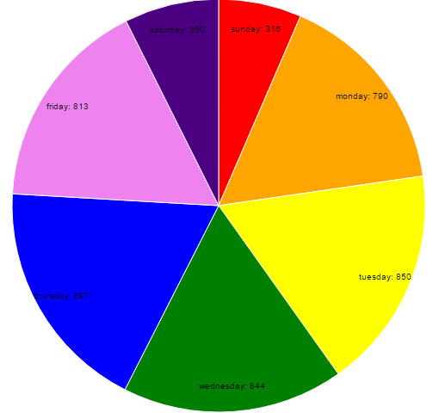 **Diagram 1: Pie chart for commits**

# **2.2 Bar graph**

The purpose of this bar graph is to show the weekly commit count of the contributors

* Use ajax to retrieve data from <https://api.github.com/repos/tungnk1993/scrapy/stats/participation>
* Parse the string data into an object
* Exclude results with 0 contributions
* Create a grid with 25 lines
* Set each tick in intervals of 10
* Create canvas, append svg
* Append grids to canvas
* Create a color scale
* Set x-axis to bottom and y-axis to left
* Shift the axes into position
* Append the data rectangles into the canvas

# 

